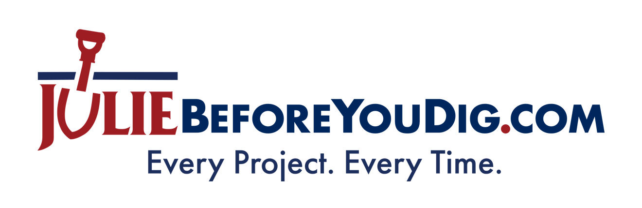

Working To Keep Our Communities Safe
Nationwide, an underground utility line is damaged every few minutes, usually from someone digging and not knowing where the lines were buried on their property. Striking a single underground utility line can cause an interruption to critical services such as electricity, natural gas, water, phone, cable TV, Internet, fiber optics, and more. It also can result in costly repairs and fees for the individual who caused the damage. Most importantly, though, someone can be seriously injured.
JULIE…Joint Utility Locating Information for Excavators…is dedicated to preventing underground utility line damage and keeping Illinoisans safe. The non-profit organization connects homeowners and professional excavators with utility companies via an easy-to-use notification system. Anyone planning a digging project can submit a request to JULIE to have underground utility lines on their property or job site located and marked for free. In fact, state law requires the person doing the digging contact JULIE at least two days, not including the day of the notice, before putting a shovel in the ground.
When marking a site, utility companies use flags, stakes or paint to indicate approximately where underground utility lines are buried. They all follow the same color codes: red for electric, yellow for gas or oil, orange for communications, blue for potable water, purple for reclaimed water, green for sewer, and pink for temporary survey. If a utility company marks an OK or NO, that means they have no underground utility lines in that area. JULIE employees will never visit a property and utilities are only required to mark lines they own, not privately installed or owned lines.
Each year, tens of thousands of DIYers in Illinois plant, build, add, and fix things outdoors, or hire professionals for projects like installing a fence, replacing a mailbox post, planting trees or shrubs, adding a deck, erecting a swing set, or putting in a pool. All of these projects require digging and therefore require the digger to contact JULIE. It’s easy to do so. Submit a locate request online 24/7/365 at JULIEBeforeYouDig.com, or call 811 or (800) 892-0123.
For more information on JULIE’s free services and learn about safe digging practices, visit JULIEBeforeYouDig.com.
# # #

